CC Lab Parthiv Abhani

Practical 1

sudo apt-get install flex bison gcc
gedit number.l
///////////////////////////
Code:

%{
#include <stdio.h>
%}

%%
zero|ZERO|Zero printf("0");
one|ONE|One printf("1");
two|TWO|Two printf("2");
three|THREE|Three printf("3");
four|FOUR|Four printf("2");
five|FIVE|Five printf("5");
six|SIX|Six printf("6");
seven|SEVEN|Seven printf("7");
eight|EIGHT|Eight printf("8");
nine|NINE|Nine printf("9");
%%

int main(){
yylex();
return 0;
}
////////////////////////////////////////////////////
lex number.l
cc lex.yy.c -ll
./a.out

//to exit, ctrl+d

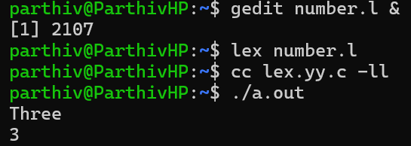

Practical 2
gedit pract2.l &
///////////////////////////////////////// Code ///////////////////////////////
%{
#include <stdio.h>
#include <string.h>

int comment_count = 0;
int keyword_count = 0;
int identifier_count = 0;
int word_count = 0;
int line_count = 0;
int space_count = 0;

char *keywords[] = {
"int", "float", "if", "else", "while", "for", "return", "void", "char", "double", "do", "switch", "case", "break", "continue", NULL
};

int is_keyword(const char *str) {
for (int i = 0; keywords[i] != NULL; i++) {
if (strcmp(str, keywords[i]) == 0)
return 1;
}
return 0;
}
%}

%%

"/*"([^*]*|\*+[^*/])*"*"+"/" { comment_count++; }

[a-zA-Z_][a-zA-Z0-9_]* {
if (is_keyword(yytext))
keyword_count++;
else
identifier_count++;
word_count++;
}

[ \t]+ { space_count += yyleng; }

\n { line_count++; }

. { word_count++; }

%%

int main() {
yylex();
printf("\n--- Code Statistics ---\n");
printf("Lines: %d\n", line_count);
printf("Comments: %d\n", comment_count);
printf("Keywords: %d\n", keyword_count);
printf("Identifiers: %d\n", identifier_count);
printf("Words: %d\n", word_count);
printf("Spaces: %d\n", space_count);
return 0;
}

int yywrap() { return 1; }

//////////////////////////////////////////////////////////////////////////////

gedit input.c &

///////////////////////// code /////////////////////////////////////////////
/* this is a comment */
int main() {
int x = 10;
float y = 5.5;
return 0;
}
/////////////////////////////////////////////////////////////
lex pract2.l
cc lex.yy.c -ll
./a.out < input.c
////OR//
./a.out
Hello hey wassap
if you go I go
press ctrl + d to exit and get output
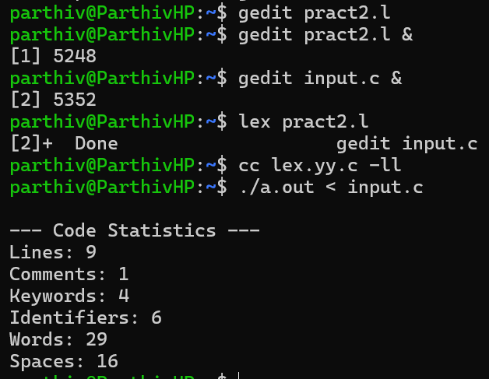

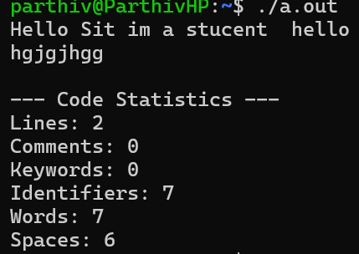

Practical 3

gedit pract3.l &
///////////////////////// code /////////////////////////////////////////////
%{
#include <stdio.h>
int wc = 0;
%}

%%
([Aa][a-zA-Z]*)[ \t\n] { wc++; }
[A-Za-z]+[ \t\n] {}
[ \t\n]+ {}
. {}
%%

int main() {
printf("Enter text:\n");
yylex();
printf("\nTotal number of words starting with A or a: %d\n", wc);
return 0;
}

int yywrap() {
return 1;
}
///////////////////////// code end /////////////////////////////////////////////

lex pract3.l
cc lex.yy.c -ll
./a.out
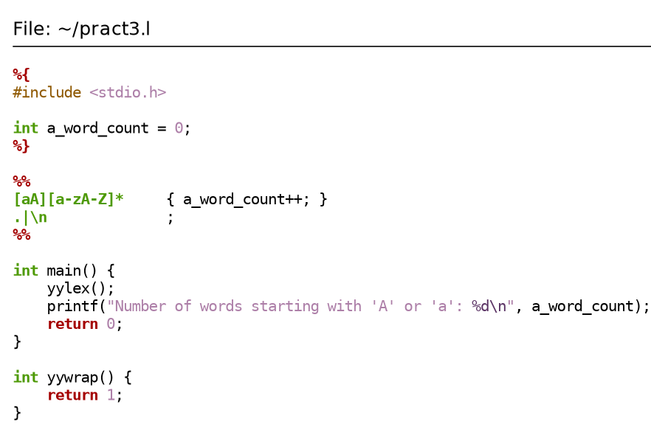
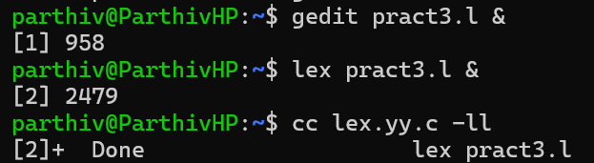
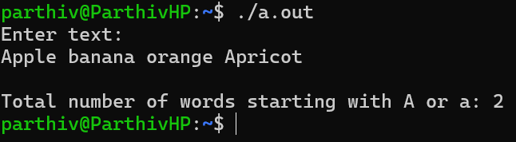

Practical 4
gedit 106pract4.l &
/////////////////////////////Code/////////////////////////////////////
%{
#include <stdio.h>
#include <ctype.h>
%}
%%
[a-z] { printf("%c", toupper(yytext[0])); }
[A-Z] { printf("%c", tolower(yytext[0])); }
.|\n { printf("%s", yytext); }
%%
int main() {
yylex();
return 0;
}
int yywrap() {
return 1;
}
////////////////////////////////////////// Code End //////////////////////////////////////////////
lex 106pract4.l
cc lex.yy.c -ll
./a.out
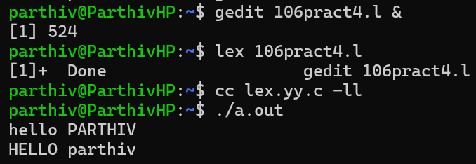
Practical 5
gedit 106Pract5.l &

////////////////////////////////////////// Code Start //////////////////////////////////////////////
%{
#include <stdio.h>
#include <stdlib.h> // for atoi()
%}
%%
[0-9]+ {
int num = atoi(yytext); // Convert string to integer
printf("%X ", num); // Print in hexadecimal (uppercase)
}
[ \t\n]+ ;
. ;
%%
int main() {
yylex();
return 0;
}
int yywrap() {
return 1;
}
////////////////////////////////////////// Code End //////////////////////////////////////////////

lex 106Pract5.l
cc lex.yy.c -ll
./a.out
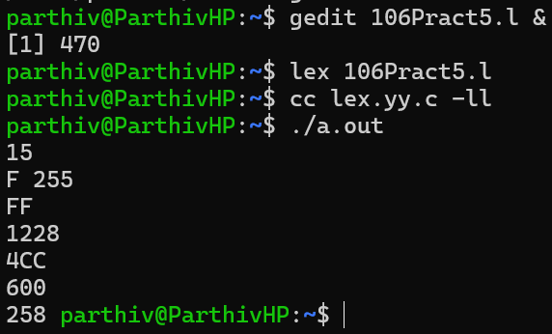

Practical 6
vi 106p6.l
////////////////////////////////////////// Code Start //////////////////////////////////////////////
%{
#include <stdio.h>
%}
%%
.*com$ { printf("Line ends with 'com': %s", yytext); }
.* { /* Ignore other lines */ }
%%
int main() {
yylex();
return 0;
}
////////////////////////////////////////// Code End //////////////////////////////////////////////
lex 106p6.l
cc lex.yy.c -ll
./a.out
